1.0 | 2025/12/17 | Final version for DISC DEXPI Continuation Project |  |  |  |  | pnb
0.1 | 2025/10/15 | initial release |  |  |  |  | pnb
Rev. | Issued date | Description |  |  |  |  | Made by
 | pnb plants & bytes GmbH
Project:
 | DISC DEXPI Continuation Project
Document title:  P&ID Verification Method |  |  |  |  |  |  |  |  | Rev:  1.0 |  | Page:  1 of 11

Table of Contents
1 Abstract 3
2 Formal Verification 4
2.1 XML Compliance 4
2.2 DEXPI Schema Compliance 5
2.3 DEXPI Specification Compliance 5
2.4 DISC Profile Compliance 6
3 Content Verification 6
4 Graphical Verification 6
5 Overall Scorecard 7
ANNEX A: Details of Content Verification 8

Abstract
The DEXPI initiative, launched in 2011, aims to establish a common data exchange standard for the process industry. Historically, most DEXPI-related work is conducted within standalone projects, with limited focus on transferring DEXPI P&ID files between different CAD vendors.
Prior to the current DISC DEXPI Continuation Project, the NOAKA DEXPI Project documents most of the requirements for DISC partners to implement DEXPI in a standardized way and addressed several gaps between the DISC requirements and the existing DEXPI specification.
This document covers one of these gaps, i.e., a method for the verification of DISC DEXPI P&ID files. The method aims to evaluate the correctness of DISC DEXPI P&ID files produced by CAE tools and thus to ensure correct data exchange via these files.

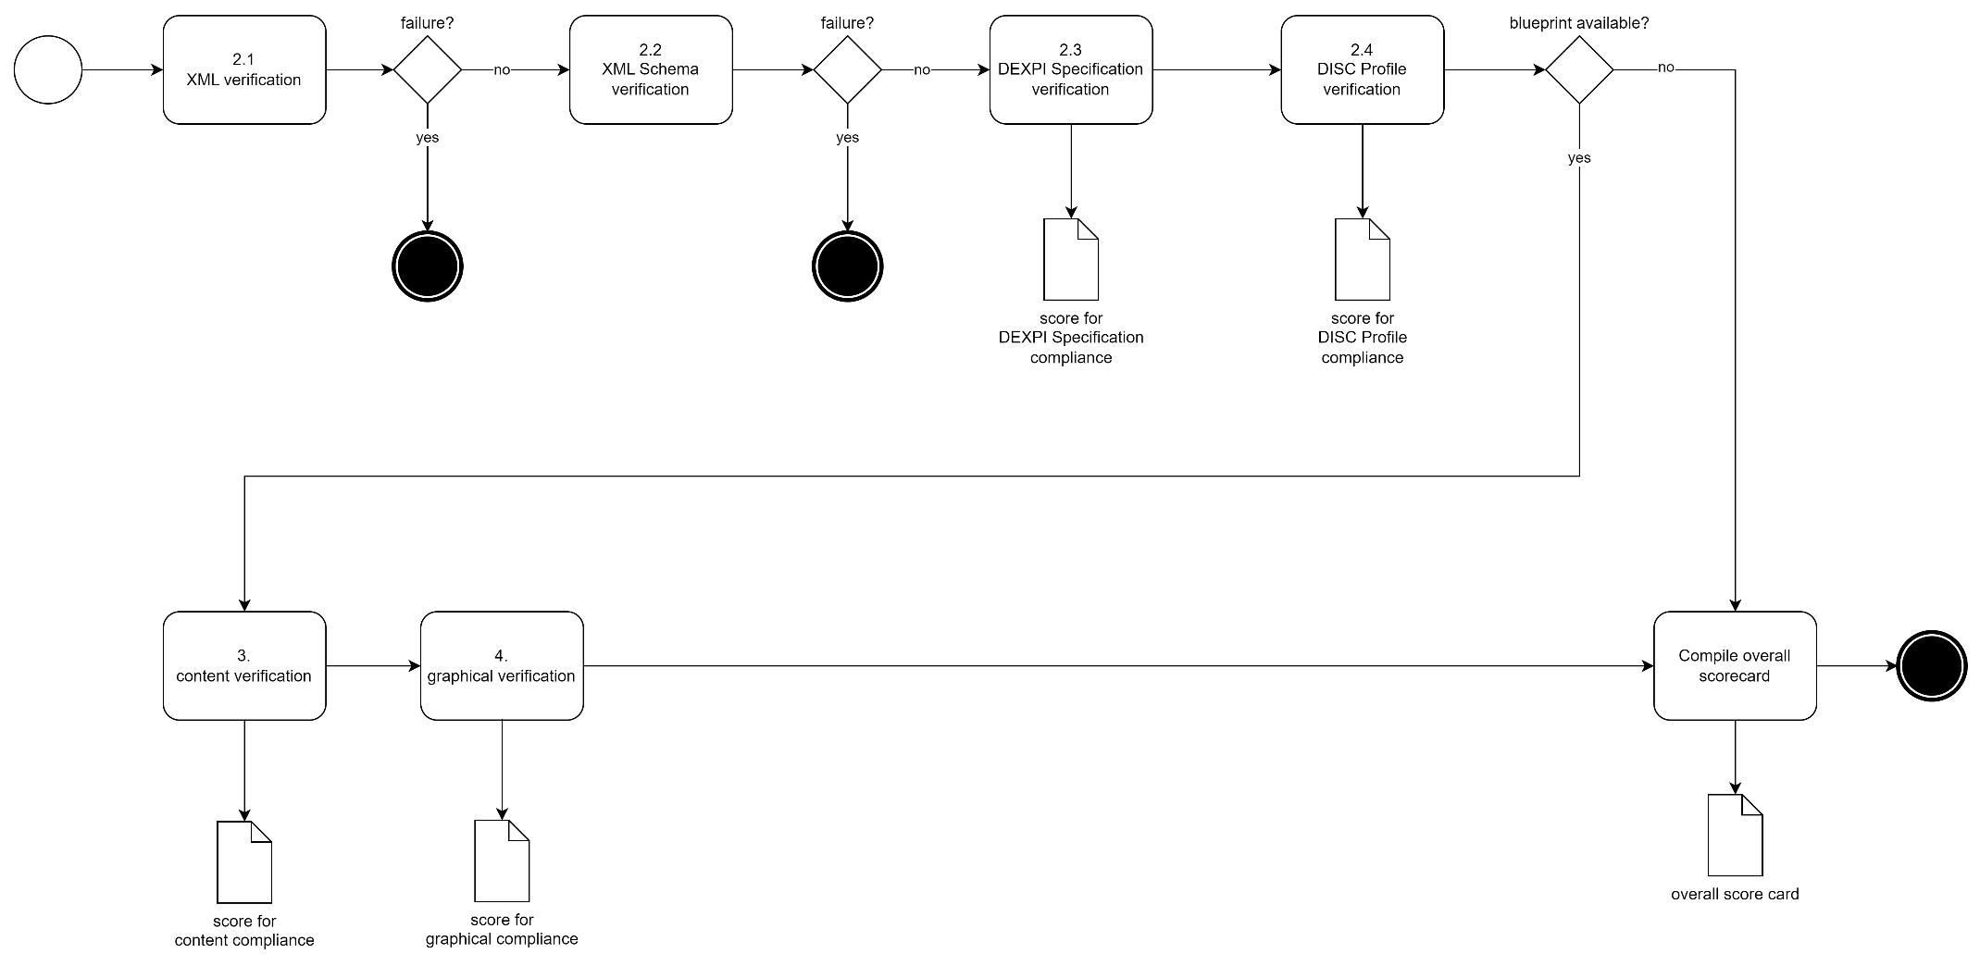

Formal Verification
Verification aims at checking the formal correctness of a DISC DEXPI P&ID file. It happens on several levels.

XML Compliance
Correct (“well-formed”) XML is indispensable for any further analysis of a DISC DEXPI P&ID file because XML libraries will typically refuse to load incorrect files (and thus make any further verification impossible). Vice-versa, XML verification can be fully automated by any compliant XML library.
Result: passed (continue) or not passed (terminate)
Underlying specification:
- Extensible Markup Language (XML) 1.0 (Fifth Edition), W3C Recommendation 26 November 2008 (https://www.w3.org/TR/REC-xml/)

DEXPI Schema Compliance
Since DEXPI 2.0, a new data format called DEXPI XML is used for the exchange of DEXPI P&IDs. A corresponding XML Schema formalizes the structure of a valid DEXPI XML file. Validation of a file with respect to the XML Schema can be fully automated with a suitable XML library.
Result: passed (continue) or not passed (terminate)
Underlying specifications:
- XML Schema (https://www.w3.org/XML/Schema)
- DEXPI XML Schema (https://dexpi.org/specifications; direct link to schema (2025-10-13): https://dexpi.gitlab.io/-/Specification/-/jobs/11676485644/artifacts/src/.build/html/html/_static/DEXPI_XML_Schema.xsd)

DEXPI Specification Compliance
The DEXPI Specification 2.0 defines constraints on DEXPI XML that are not covered by the DEXPI XML Schema. In particular, these constraints ensure the conformance of P&ID data with DEXPI Plant, an information model for P&IDs. For an automated check of these constraints, specific software is required.
Result:
$$score = 100-\frac{100* number of violated constraints}{number ofobjects+number of data values+number of links}$$
- number of links is the number of correct property values (composition, reference, data).
- A score smaller than 0 is capped, i.e., 0 ≤ score ≤ 100.
- score is rounded to the nearest integer.
Underlying specification:
- DEXPI Specification 2.0.0 or later (https://dexpi.org/specifications)

DISC Profile Compliance
Beyond extending the DEXPI Plant information model, the DISC DEXPI Profile imposes additional constraints on a correct P&ID. For example, the profile prescribes the symbols to be used for certain conceptual objects, and it defines certain attributes as mandatory.
Result:
$$score = 100-\frac{100* number of violated constraints}{number ofobjects+number of data values+number of links}$$
- number of links is the number of correct property values (composition, reference, data).
- A score smaller than 0 is capped, i.e., 0 ≤ score ≤ 100.
- score is rounded to the nearest integer.
Underlying specification:
- DISC DEXPI Pilot Transfer Requirements and other documents created in the project
- DISC DEXPI Profile

Content Verification
A verification of the content of a P&ID is possible if there is a blueprint P&ID that contains the expected content. The blueprint P&ID must be available as a DISC DEXPI file, and it should be fully compliant from a formal point of view (i.e., a verification according to 2.1 and 2.2 should result in passed, and a verification according to 2.3 and 2.4 should result in a score of 100).
The actual content verification happens by comparing the content of the P&ID to verify with the content of the blueprint P&ID. A proposal for content verification is given in Annex A. This proposal will lead to a score in the range from 0 to 100 %.

Graphical Verification
In general, an evaluation of the appearance of the diagram depends on the expectations and requirements of the users. In DISC DEXPI, it is required that diagram layout completely kept after an import/export cycle. However, small deviations due to the different internal graphics models of the involved tools cannot be fully excluded.
For now, a visual comparison by a human being is proposed. This could be simplified by a tool that enables to overlay two diagrams so that differences can be spotted more easily.
A rough scoring system (unacceptable=0 %, bad=25 %, medium=50 %, good=75 %, perfect=100 %) is proposed.

Overall Scorecard
An overall scorecard should summarize the individual results and scores. It should further give meta information such as
- name, version, date, tool, tool version of verified P&ID,
- name, version, date of blueprint,
- person/organization who has done the verification,
- name, version of any tools used for the verification,
- data of verification.

ANNEX A: Details of Content Verification
The idea of content verification is to check for each object in the conceptual model of the blueprint if there is a matching object in the conceptual model to verify. If such a matching object exists, it is checked if all its attribute values match those in the blueprint (scoring).

Object Matching
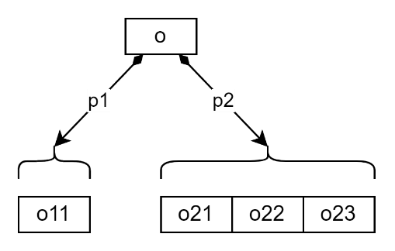
Figure 1
Figure 1 shows the principle of the object hierarchy in the conceptual model. An object o can have components which are linked via composition properties p1, p2, etc. In the example, there is one component o11 linked via composition property p1, and there are three components o21, o22, and o23 linked via composition property p2. Depending on its type, each component may have sub-components.
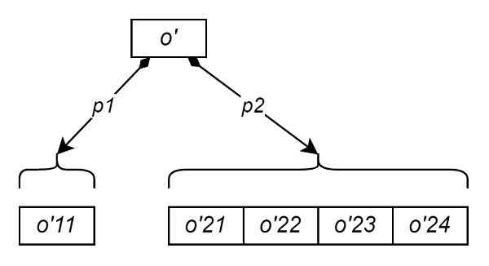
Figure 2
Figure 2 shows a second object hierarchy; objects are marked with a prime symbol. We assume that Figure 2 is an excerpt from the blueprint and Figure 1 an excerpt from the P&ID to verify.
Further, we assume that we know that o matches o’. At the beginning, we know that the conceptual model of the blueprint matches the conceptual model of the P&ID to verify, and we are ready to match their respective components. When these components are matched, their sub-components can be matched, etc.
Object matching is done separately for each property. For p1, there is only one component object in both models, and it is clear that we have to match o11 with o’11. For the components via p2, the matching is ambiguous. The goal is to match as many objects as possible and to leave superfluous objects unmatched. In the example, only three of the four p2-components o’ can be matched; one will remain unmatched.
A straightforward approach to the matching problem is to formulate it as an optimization problem. To simplify the notation, we omit the index for the property (matching is done separately for each property).
Let O and O’ be sets.
These are the two sets of objects to be matched.
Let f: O x O’→R.
f is an evaluation function that for each pair of an object from O and an object from O’ indicates “how good the objects match”.
Let M ⊆ O x O’ be a relation (set of pairs).
M describes a possible matching.
Then, the optimization problem is to maximize
$$\sum_{\left(o, o^{'}\right)∈M}{f(o, o')}$$
This means that we want to find M such that the overall quality of the matching has the highest possible value.
There are some conditions M must fulfil:
- We want to match as many objects as possible. This means that M must contain n pairs, where n is the number of objects in the smaller set O or O’.
- Each object from O and O’ may appear at most once in M.
A naive approach to solve the optimization problem is to calculate the overall quality for each possible matching. A more efficient approach is for example that by D.F. Crouse. Crouse provides an implementation in MATLAB. The SciPy library provides an alternative Python implementation.
The exact definition of the evaluation function f is still open. Based on experiences from the NOAKA DEXPI project, we propose to define f(o, o’) for a pair of objects (o, o’) as the sum of the points listed in the table below. Note that depending on the object types, not all rows can always be considered (e.g., SourceNode and TargetNode are defined for PipingConnections).

Points | Condition
10 | o and o’ have same PersistentIdentifier
5 | o and o’ have same type
5 | o and o’ have same ObjectDisplayName
3 | o and o’ have matching SourceItems
3 | o and o’ have matching SourceNodes
3 | o and o’ have matching TargetItems
3 | o and o’ have matching TargetNodes
It may be useful to adapt the points when experiences with real P&IDs are available.

Scoring

After the conceptual objects of the blueprint are matched (where some may remain unmatched, see above), points for each object are calculated as follows:
Points | Condition
5 | matched object has correct type
1 | for each correct data value in the matched object
1 | for each correct reference value in the matched object (note that this includes a check for correct piping topology)
-1 | for each superfluous value in the matched object (it may make sense to accept superfluous values for some properties such as TagName that are not used in DISC)

The overall points are the sum of the points for each conceptual object from the blueprint.

Finally, the score is calculated as follows:
$$score = 100-\frac{100* actual points}{max possible points}$$
- A score smaller than 0 is capped, i.e., 0 ≤ score ≤ 100.
- score is rounded to the nearest integer.

Handling of PipingNetworkSegments

PipingNetworkSegments are a composition layer enforced by DEXPI between PipingNetworkSystems and the “low-level” topology elements such as valves and pipes. However, PipingNetworkSegments are handled differently in different CAE tools such that the matching and scoring algorithms described above will fail.

Thus, the conceptual models from the blueprint and the P&ID to verify are restructured as follows:

The data property values in each PipingNetworkSegment (nominal diameter, piping class, etc.) are moved to the components of the PipingNetworkSegment (pipes, valves, etc).

The components of each PipingNetworkSegment (pipes, valves, etc.) are moved to the PipingNetworkSystem that owns the PipingNetworkSegment.

The PipingNetworkSegments are removed.

Note that no information is lost in these steps, except the grouping of low-level elements in PipingNetworkSegments.

In the restructured model, the matching and scoring algorithms can be applied as described above.

During the development of DEXPI XML Schema on behalf of DEXPI e.V., pnb has checked if conventional XML libraries are able to handle the schema correctly. For these libraries no issues were detected: - .NET implementation by Microsoft (namespace System.Xml.Schema). - Python: lxml version 5.4.0. lxml uses the C library libxml2, so other language bindings of libxml2 may be good candidates for other languages than Python. - Java: javax.xml.validation package.
In case of DISC DEXPI, an extension of the DEXPI Plant information model is used that accounts for specific requirements of the stakeholders within the DISC DEXPI Continuation Project. This extension is formalized in the DISC Profile. Profiles are not yet an official feature of DEXPI 2.0, but their impact on conformance checking of data w.r.t. an information model is straightforward.
Note that the composition properties in the conceptual model are not ordered. The order/indexing of the objects is not relevant.
D.F: Crouse. On implementing 2D rectangular assignment algorithms. IEEE Transactions on Aerospace and Electronic Systems, 52(4):1679-1696, August 2016, DOI:10.1109/TAES.2016.140952
https://scipy.org. The optimization algorithm linear_sum_assignment is part of the scipy.optimize package.

